

Name : Tan Yin Ling

Login ID : R03412910@oasis-portal.my

Course title : Executive Diploma in Culinary Arts & Hospitality Management

Subject Code : CA03 International Cuisine

Submitted date: 0**7/09/ 2017**

**Table of Contents**

|  |  |  |
| --- | --- | --- |
| **No** | **Details** | **Page** |
| 1 | Executive Summary | 2 |
| 2 | Introduction | 3-5 |
| 3 | Assignment Question |  |
|  | Part 1 | 6-9 |
|  | Part 2 | 10-13 |
|  | Part 3 | 14-16 |
| 4 | Conclusion | 17 |
| 5 | References | 18 |

**Executive Summary**

In this assignment we will learn about the purpose of this unit that is to be able to understand International Cuisine within Culinary Arts and Hospitality Management.

We will need to choose one dish from each cuisine. The cuisines are Chinese, Indian and Western. From each cuisine we will need to recreate or alter the original recipe into our own recipe.

I can learn different cutting skill like medium dice, brunoise, fine julienne and other in Chinese cooking skill. Indian Cuisines will more spicy taste and put a variety of spices. For example star anise, cinnamon and cumin. Other than that, Western Cuisine are different from Chinese Cuisine. Western Cuisine will use of olive oil, butter, salad dressing and other seasoning.

**Introduction**

International cuisine that is practiced around the world. A cuisine is a characteristic style of cooking practices and traditions, often associated with a specific region, country or culture. For example the International Cuisine in Malaysian is

**For Thailand**

>Tom Yum Goong (Spicy Shrimp Soup)

>Som Tum (Spicy Green Papaya)

>Tom Kha Kai (Chicken in Coconut Soup)

>Gaeng Daeng (Red Curry)

>Pad Thai (Thai style Fried Noodles)

>Khao Pad (Fried Rice)

>Pad Krapow Moo Saap (Fried Basil and Pork)

>Gaeng Keow Wan Kai (Green Chicken Curry)

>Yam Nua (Spicy Beef Salad)

>Kai Med Ma Muang (Chicken with Cashew Nuts)

**For Japan**

**>**Sushi

**>**Ramen

**>**Unagi

**>**Tempura

**>**Kaiseki

**>**Shabu-Shabu

**>**Okonomiyaki

**>**Tonkatsu

**>**Yakitori

**For China**

>Sweet and Sour Pork

>Gong Bao Chicken

>Ma Po Tofu

>Wontons

>Dumplings

>Chow Mein

>Peking Roasted Duck

>Spring Rolls

**For French**

>Coq au vin

>Cassoulet

>Beef bourguignon

>Chocolate soufflé

>Flamiche

>Confit de canard

>Nicoise salad

>Ratatouille

>Tarte tatin

**For Taiwan**

>Braised pork rice

>Beef noodles

>Oyster omelet

>Milkfish

>Slack Season danzai noodles

>Pan-friend buns

>Gua bao

>Iron egg

>Pineapple cake

>Tian bu la (Taiwanese oden)

**For United States**

>New York-Style Pizza

>Hoppin’ John

>Tasso Ham

>Buttermilk Biscuits

>Maine Lobster

>Shrimp and Hushpuppies

>Barbecue Ribs

>Fish Tacos

>Cheese Curds

>Key Lime Pie

**Assignment Questions**

You should create your own dish from each international cuisine listed.

Required:

Choose one dish for each cuisine:

(i) Chinese cuisine

(ii) Indian Cuisine

(iii) Western Cuisine

**(i) Chinese Cuisine**

**Chow Mein**

**Recipe**

Serves 2|Prep Time:10 Minutes| Cook Time: 5 Minutes

Ingredients:

8 oz. steamed chow mein

1 tablespoon soy sauce

1 tablespoon oyster sauce

½ teaspoon sugar

½ teaspoon Chinese dark soy sauce

2 tablespoons water

2 tablespoons oil

3 garlic cloves, finely minced

2 oz. chicken, cut into thin strips

6 shrimp, shelled and deveined

½ cup shredded cabbage

¼ cup shredded carrot

2 stalks scallions, cut into 2-inch strips

Method:

Soak the steamed chow mein in cold water for about 5 minutes. Rinsea few times until the water turns clear and the chow mein is soft. Drain the excess water and set aside.(Don’t over soak the chow mein or the noodles will get limpy and soggy.)

In a small mixing bowl, mix the soy sauce, oyster sauce, sugar, dark soy sauce and water together. Set aside.

Heat up a skillet or wok with the oil. Add in the garlic and stir-fry until light brown or aromatic. Add the shredded cabbage and carrot into the wok and do a few quick stirs. Add the noodles and the soy sauce mixture. Continue to stir fry until the noodles are well combined with the soy sauce mixture and completely cooked through. Add the chopped scallions, do a few final stirs, dish out and serve hot.

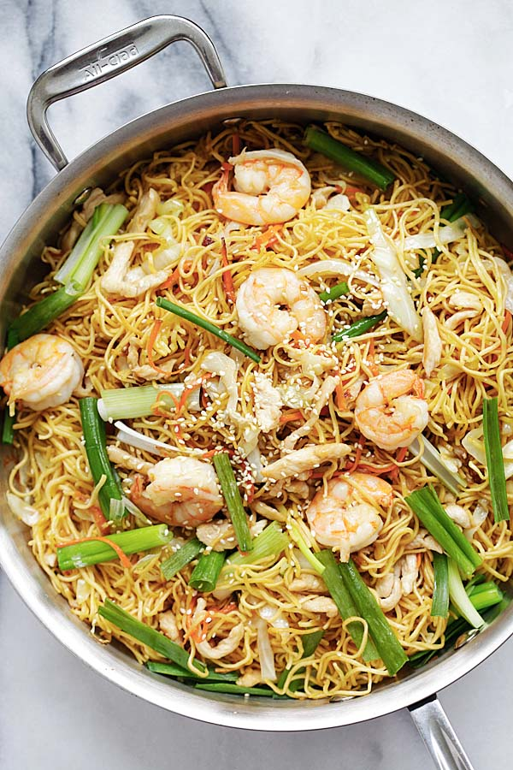 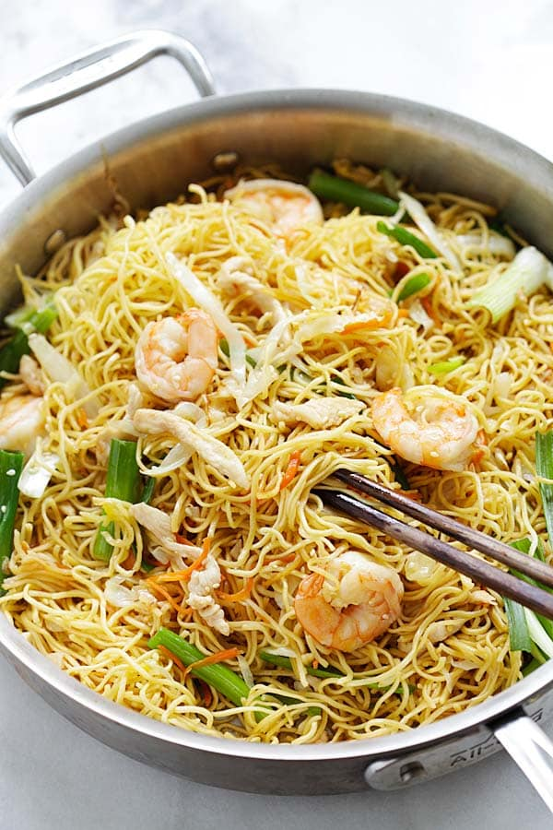

**Own Recipe**

**Beef fried noodles (niu rou chow mein)**

Serves 1| Prep time:10 minutes| Cook time: 5 minutes

**Ingredients:**

4 oz. steamed chow mien

½ tablespoon soy sauce

1 teaspoon sugar

½ teaspoon salt

1 teaspoon Chinese dark soy sauce

1 tablespoon water

1 tablespoon oil

2 garlic cloves, finely minced

½ onions, sliced

1 oz. beef, cut into thin strips

¼ cup shredded cabbage

¼ cup shredded carrot

**Method:**

1. Soak the steamed chow mein in cold water for 5 minutes. Drain the excess water and set aside when chow mein is solf.
2. Heat up a wok with the oil.Add in the garlic and onions to stir-fry until golden. Add the shredded cabbage and carrot into the wok and do a few quick stir. Add the beef stir fry until they are half cooked. Add the noodles and do a few stirs. Than add the soy sauce, sugar, salt, dark soy sauce and water. Continue to stir fry until the noodles are well combined with the sauce and completely cooked through. Dish out and serve hot.

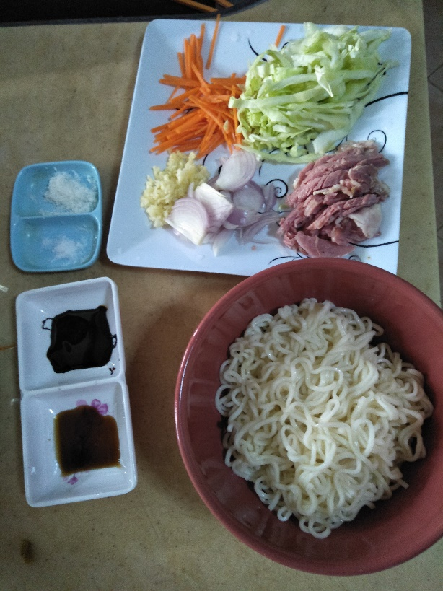

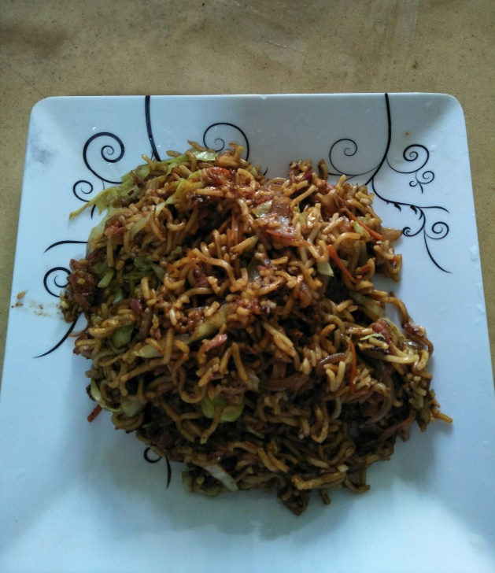

**(ii) Indian Cuisine**

**India Vegetable Curry**

**Recipe**

Serves 4-6|Hands-on Time:45-50 Minutes

**Ingredients:**

Sunflower oil for frying

2 red onions, finely sliced

5cm piece fresh ginger, finely chopped

1 teaspoon ground coriander

1 tablespoon garam masala

1 teaspoon ground cumin

2 large maris piper potatoes, cut into 1cm cubes

1-2 green chillies, finely sliced (optional)

3 garlic cloves, finely chopped

400g can chopped tomatoes

500ml vegetable stock

4 dried kashmiri/Indian chillies, soaked for 10 minutes in boiling water, then roughly chopped

2 teaspoon caster sugar

1 large head broccoli, cut into small florets

250ml full-fat Greek yogurt

200g baby leaf spinach

Juice 1-2 limes

Large handful fresh coriander

Flatbreads such as chapatis or rotis to serve

**Method:**

01.Heat a good glug of oil in a large, deep frying pan, then fry the onions over a medium heat. Cook for 2-3 minutes, stirring, then add the ginger and dry spices and fry for 2-3 minutes more. The onion should brown a little, but not get too dark.

02.Add the potatoes, green chilli/es (if using) and garlic to the pan, then fry for 8-10 minutes, stirring every now and then, until the potatoes start to yield when pressed. If the mixture gets too dry, add a little more oil or a splash of water.

03.Add the chopped tomatoes, stock and the chopped, soaked chillies. Simmer for 5 minutes, then add the sugar and broccoli. Simmer for a further 5 minutes, then stir in the yogurt, spinach, half the lime juice and half the coriander. Taste and add the rest of the lime juice if you think it needs it. Simmer until the spinach has wilted. If you want the curry a touch thinner, add a splash of water. Sprinkle the curry with the rest of the coriander sprigs and serve with chapatis or rotis.

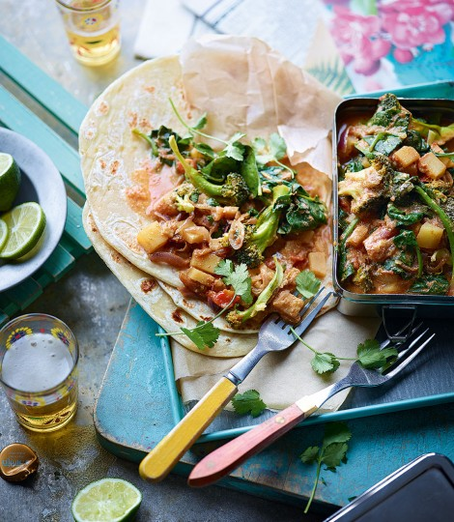

**Own Recipe**

**India Mango Vegetable Curry**

**Recipe**

Serve 2| Hands-on Time: 40 Minutes

**Ingredients:**

Sunflower oil for frying

½ onions, finely sliced

1 large potatoes, cut into cubes

1-2 little red chilies, finely sliced

1 green mango, cut into 2-inch strips

½ cup parsley, cut into 2-inch strips

¼ cup sliced cabbage

½ pack of flammulina

3 tablespoons vegetable curry power

1 teaspoon sugar

½ teaspoon salt

**Method:**

1. Heat up a wok with oil and fried potatoes until start to yield when pressed. Set aside.
2. Heat up a wok with oil and add onions to stir-fry until golden. Add the little red chilies, sliced cabbage, flammulina and parsley to the wok, then fry for 5 minutes. Add the vegetable curry power, salt and sugar do a few quick stirs.
3. Add a splash of water and wait it boiling. Than add the potatoes and green mango. When the potatoes is soft dish outand serve hot.

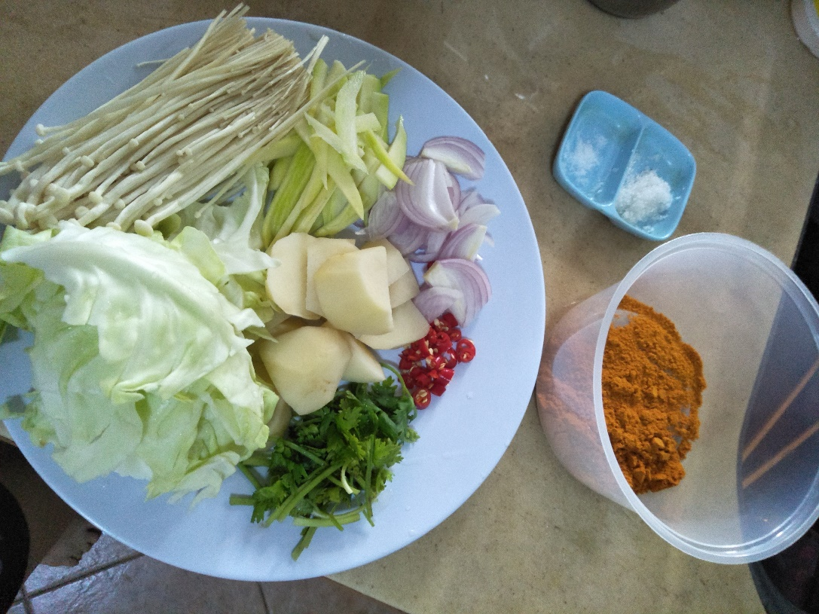

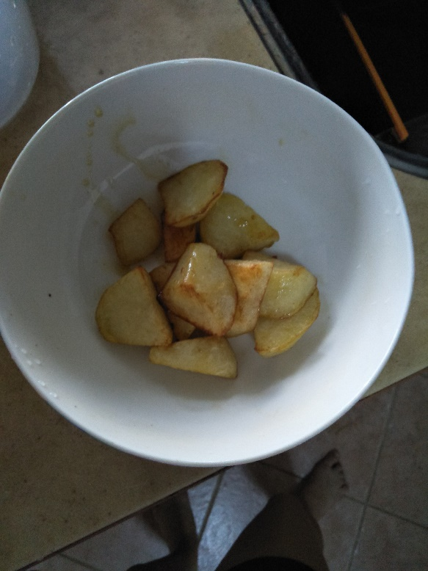 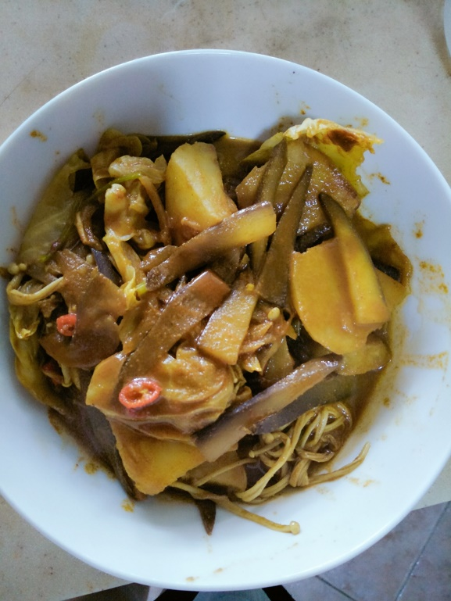

**(iii) Western Cuisine**

**French Toast**

**Recipe**

Prep Time:5 Minutes| Cook Time: 15 Minutes| Ready in: 20 Minutes

**Ingredients:**

6 thick slices bread

2 eggs

2/3 cup milk

¼ teaspoon ground cinnamon (optional)

¼ teaspoon ground nutmeg (optional)

¼ teaspoon vanilla extract (optional)

Salt to taste

**Directions:**

1. Beat together egg, milk, salt, desired spices and vanilla.

2. Heat a lightly oiled griddle or skillet over medium-high heat.

3. Dunk each slice of bread in egg mixture, soaking both sides. Place in pan, and cook on both sides until golden. Serve hot.

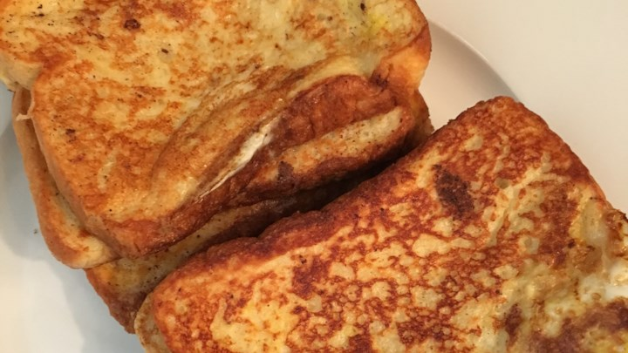

**Own Recipe**

**Chinese Sausage Cheese Toast**

**Recipe**

Prep Time: 5 minutes| Cook time: 15 minutes| Ready in: 20 minutes

**Ingredients:**

4 thick slice bread

2 eggs

1 Chinese sausage

4 piece cheese

A little butter

**Direction:**

1. Each piece of bread in the middle of a piece of cheese and Chinese sausage, slowly rolled up, dipped in some egg sealing.
2. Heat up a frying pan with butter. Add the toast with sticky the egg cream into the pan frying with medium-high heat.
3. Frying until golden. Serve hot.

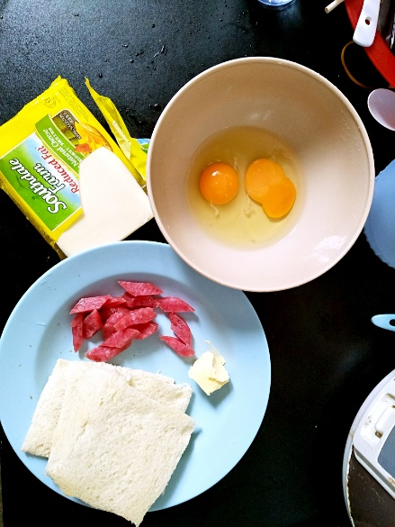 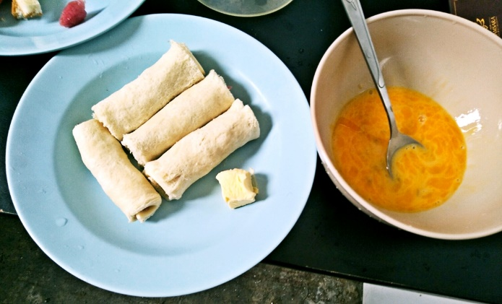

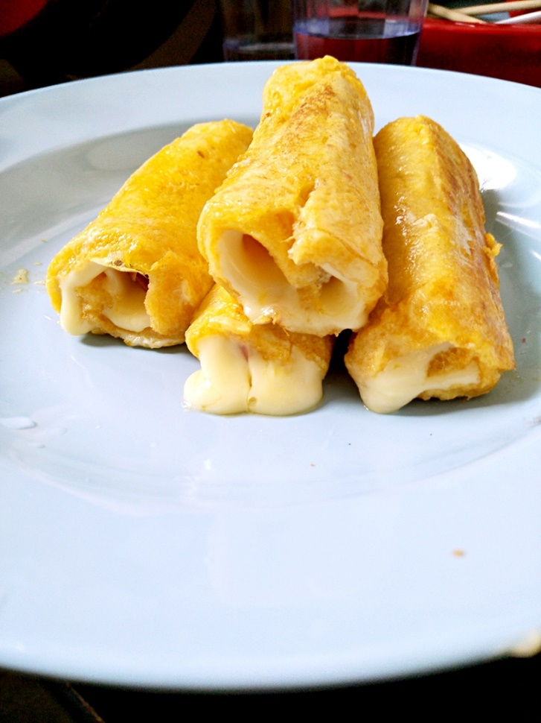

**Conclusion**

International cuisine refers to the foods that are common in the countries.

In this assignment, I can learn about the international cuisine are representing different countries. Every country has its own international cuisine, they are formed according to different lifestyle, skill, culture and weather. We can explores countries and regions and ingredients and describes the crucial role they play in different world cuisines.

International cuisine provides students, teachers and professionals in foodservice a window to a wide variety of the world’s cuisines.

**References**

Unknown, Unknown, Online source, Chow Mein

<http://rasamalaysia.com/chow-mein-chinese-noodles-recipe/>

Unknown, Unknown, Online source, Indian Vegetable Curry

<http://www.deliciousmagazine.co.uk/recipes/indian-vegetable-curry/>

Jan Bittner, Unknown, Online source, French Toast

<http://allrecipes.com/recipe/7016/french-toast-i/>